ORALSCAN AI_Y1
YOLO26-M Instance Segmentation
Complete Study & Technical Documentation

Purpose: long-term study, reproducibility, workflow understanding, and AI_C1 integration reference
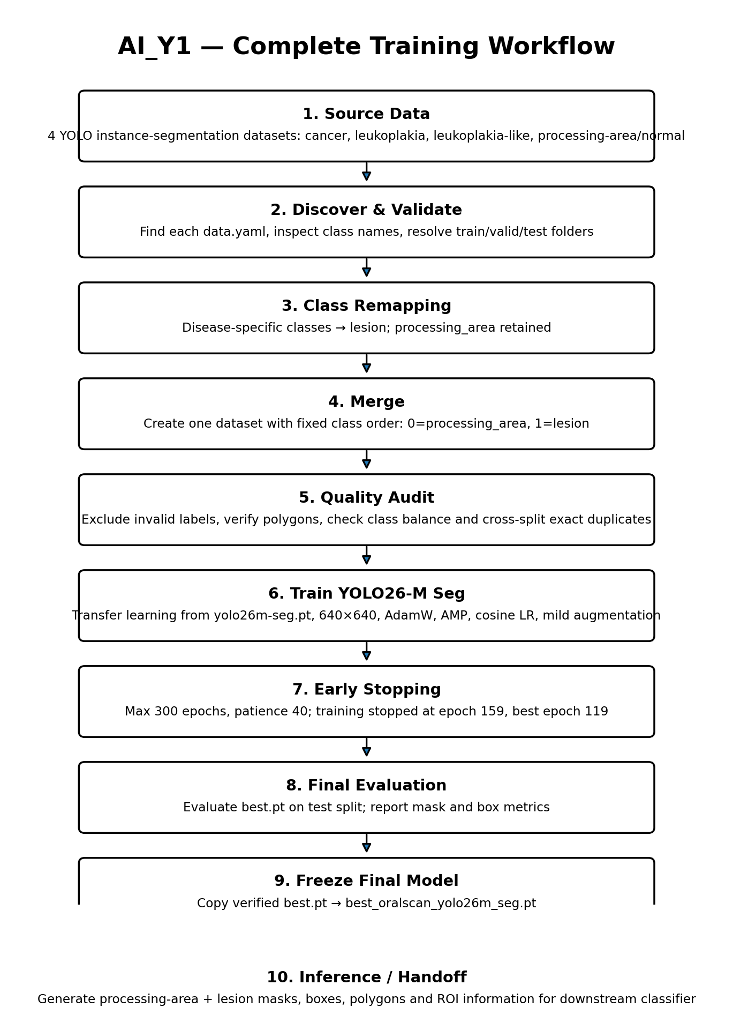
Source notebook: ai_y1(3).ipynb
Final segmentation model: best_oralscan_yolo26m_seg.pt

1. One-Page Quick Reference
Item | Final AI_Y1 configuration
Task | Instance segmentation of oral images
Base checkpoint | yolo26m-seg.pt
Final model file | best_oralscan_yolo26m_seg.pt (verified copy of best.pt)
Classes | 0 = processing_area; 1 = lesion
Input size | 640 × 640
Source datasets | 4 separate YOLO segmentation datasets
Raw source images | 817
Valid merged images | 812 after excluding 5 invalid/empty samples
Merged split | Train 574 | Valid 156 | Test 82
Max epochs / patience | 300 / 40
Actual stop | 159 epochs; best observed at epoch 119
Optimizer | AdamW
Mixed precision | AMP enabled
Training GPU in recorded run | NVIDIA A100-SXM4-40GB
Training duration in recorded run | 38.06 minutes
Primary role | Locate/segment oral processing region and lesion region; produce masks/geometry for AI_C1

Study Note: AI_Y1 does not perform the final four-class disease diagnosis. Its job is segmentation/localization. AI_C1 uses the regions produced by AI_Y1 for classification.

2. Objective and Role in the Complete OralScan System
AI_Y1 is the first-stage vision model in the OralScan pipeline. It converts a full oral image into spatially meaningful regions. The model distinguishes the general oral processing region from lesion regions, allowing the downstream classifier to focus on anatomically relevant content rather than the entire raw image.
- Detect and segment the processing_area in every usable oral image.
- Detect and segment lesion regions in disease-source images when present.
- Return masks, boxes, polygon coordinates, object counts and confidence scores.
- Provide ROI information that can be consumed by the AI_C1 classifier pipeline.

3. Dataset: Source Structure and Final Mapping
The notebook discovers four independent Roboflow-style YOLO instance-segmentation datasets. Each dataset already contains train/valid/test folders and its own data.yaml. Disease-specific lesion names are unified into a single lesion class.
Source dataset | Original source classes | Final mapping | Raw images
cancer_detection.v1i.yolov11 | cancer-detection, processing_area | cancer-detection → lesion; processing_area → processing_area | 200 (140/40/20)
leukoplakia_detection.v1i.yolov11 | leukoplakia-detection, processing_area | leukoplakia-detection → lesion; processing_area → processing_area | 200 (140/38/22)
leukoplakia_like_detection.v1i.yolov11 | leukoplakia-like-detection, processing_area | leukoplakia-like-detection → lesion; processing_area → processing_area | 202 (142/40/20)
processing_area.v2i.yolov11 | processing_area | processing_area → processing_area | 195 (155/40/20)

3.1 Frozen final class order
FINAL_CLASS_NAMES = {
0: 'processing_area',
1: 'lesion'
}
Study Note: This class order is critical. Both training and inference explicitly verify it. A model with reversed IDs would break all downstream logic.

3.2 Final merged dataset
Split | Images | processing_area images | Lesion-positive images | processing_area polygons | Lesion polygons | Lesion-negative images
Train | 574 | 574 | 418 | 596 | 516 | 156
Valid | 156 | 156 | 117 | 163 | 139 | 39
Test | 82 | 82 | 62 | 89 | 83 | 20
Total | 812 | 812 | 597 | 848 | 738 | 215

4. Dataset Preparation, Remapping and Quality Control
The data-preparation cell performs more than concatenation. It discovers datasets, resolves split folders, validates YOLO polygon lines, maps every source class into the frozen two-class scheme, prefixes filenames to avoid collisions, and creates a new merged data.yaml.
Stage | What happens
ZIP extraction | Extract the uploaded source ZIP into a dedicated workspace.
Dataset discovery | Recursively discover valid data.yaml files that have YOLO split folders.
Class-name normalization | Normalize source class names and map processing-related aliases to processing_area and disease-related aliases to lesion.
Polygon validation | Read segmentation labels, check class IDs and normalized polygon coordinates, and remap class IDs.
Required processing-area check | Samples without a usable processing_area polygon are treated as invalid for this pipeline.
Collision-safe merge | Prefix destination filenames using source-dataset information before copying image/label pairs.
Manifest/report generation | Create mapping, excluded-sample, duplicate and merged-manifest reports.
Final data.yaml | Write a single training YAML with names {0: processing_area, 1: lesion}.

4.1 Excluded samples
Problem | Count
Empty annotation file | 4
processing_area polygon missing | 1
Total excluded | 5

Therefore: 817 source images → 812 valid merged images.

4.2 Duplicate audit
The notebook computes SHA-256 hashes and reports exact images that occur across more than one split. The recorded run found 19 cross-split duplicate hash groups (one group appeared in all three splits). The code reports these duplicates to CSV rather than silently removing/re-splitting them.
Study Note: For future scientific evaluation, the cross-split duplicate report should be reviewed because exact duplicates across train/valid/test can affect how independently the evaluation reflects generalization. This is a documented property of the recorded dataset preparation, not a hidden correction.

5. Model and Training Configuration
The final segmentation model is built by transfer learning from the Ultralytics YOLO26-M segmentation checkpoint. The notebook keeps the standard architecture and tunes training behavior for the small clinical image dataset and an A100 GPU.
Parameter | Value | Why it matters in this notebook
Checkpoint | yolo26m-seg.pt | Pretrained YOLO26-M instance-segmentation model
Image size | 640 | All training/validation inference uses 640-pixel input size
Max epochs | 300 | Upper limit; early stopping controls actual duration
Early-stop patience | 40 | Stops when no improvement is observed for 40 epochs
Batch size | 16 | Recorded stable A100 setting
Workers | 8 | Data-loading workers
Optimizer | AdamW | Fine-tuning optimizer
Initial LR | 0.0005 | Conservative transfer-learning learning rate
Final LR factor | 0.01 | Cosine schedule endpoint factor
Weight decay | 0.0005 | Regularization
Warmup | 5 epochs | Warm-up before full-rate optimization
Cosine LR | True | Learning-rate decay schedule
AMP | True | Mixed-precision training
Seed | 42 | Reproducibility
Deterministic | True | Deterministic training request

6. Data Augmentation Strategy
Augmentation is intentionally mild because these are close-range clinical photographs. The notebook avoids aggressive geometric distortion and does not add blur augmentation because the dataset already contains naturally soft-focus images.
Augmentation | Setting
Rotation | degrees = 10.0
Translation | 0.05
Scale | 0.15
Shear | 0.0
Perspective | 0.0
Horizontal flip | 0.50
Vertical flip | 0.0
HSV hue | 0.01
HSV saturation | 0.20
HSV value | 0.20
Mosaic | 0.30; disabled for final 20 epochs
MixUp | 0.0
Copy-paste | 0.10

7. Training Outcome and Model Selection
The configured maximum was 300 epochs, but early stopping terminated the recorded run after 159 epochs because there had been no improvement for 40 epochs. Ultralytics reported the best result at epoch 119. The notebook explicitly copies and verifies best.pt, not last.pt, as the deployable model.
Recorded training result | Value
Completed epochs | 159 / 300
Best epoch | 119
Training duration | 38.06 minutes
Best checkpoint | .../weights/best.pt
Final copied model | /content/best_oralscan_yolo26m_seg.pt
Final model size | 51.98 MB
Fused model parameters | 23,509,010
Fused GFLOPs | 121.4

8. Final Test Evaluation
The final verified best checkpoint was evaluated on the TEST split (82 images, 172 total instances). The following values are directly from the recorded notebook run.
Overall metric | Value
Mask Precision | 0.6125
Mask Recall | 0.5271
Mask mAP@0.50 | 0.4683
Mask mAP@0.50:0.95 | 0.2081
Box Precision | 0.7273
Box Recall | 0.7124
Box mAP@0.50 | 0.7095
Box mAP@0.50:0.95 | 0.4493

Class | Images / Instances | Mask P | Mask R | Mask mAP50 | Mask mAP50-95 | Box mAP50 | Box mAP50-95
processing_area | 82 / 89 | 0.607 | 0.584 | 0.487 | 0.253 | 0.924 | 0.705
lesion | 62 / 83 | 0.618 | 0.470 | 0.450 | 0.164 | 0.495 | 0.194

Study Note: The model is clearly stronger at localizing the processing_area than lesions in the recorded test run. This is important when interpreting AI_C1 inputs: lesion ROI quality is more uncertain than processing-area localization.

9. Final Inference Pipeline
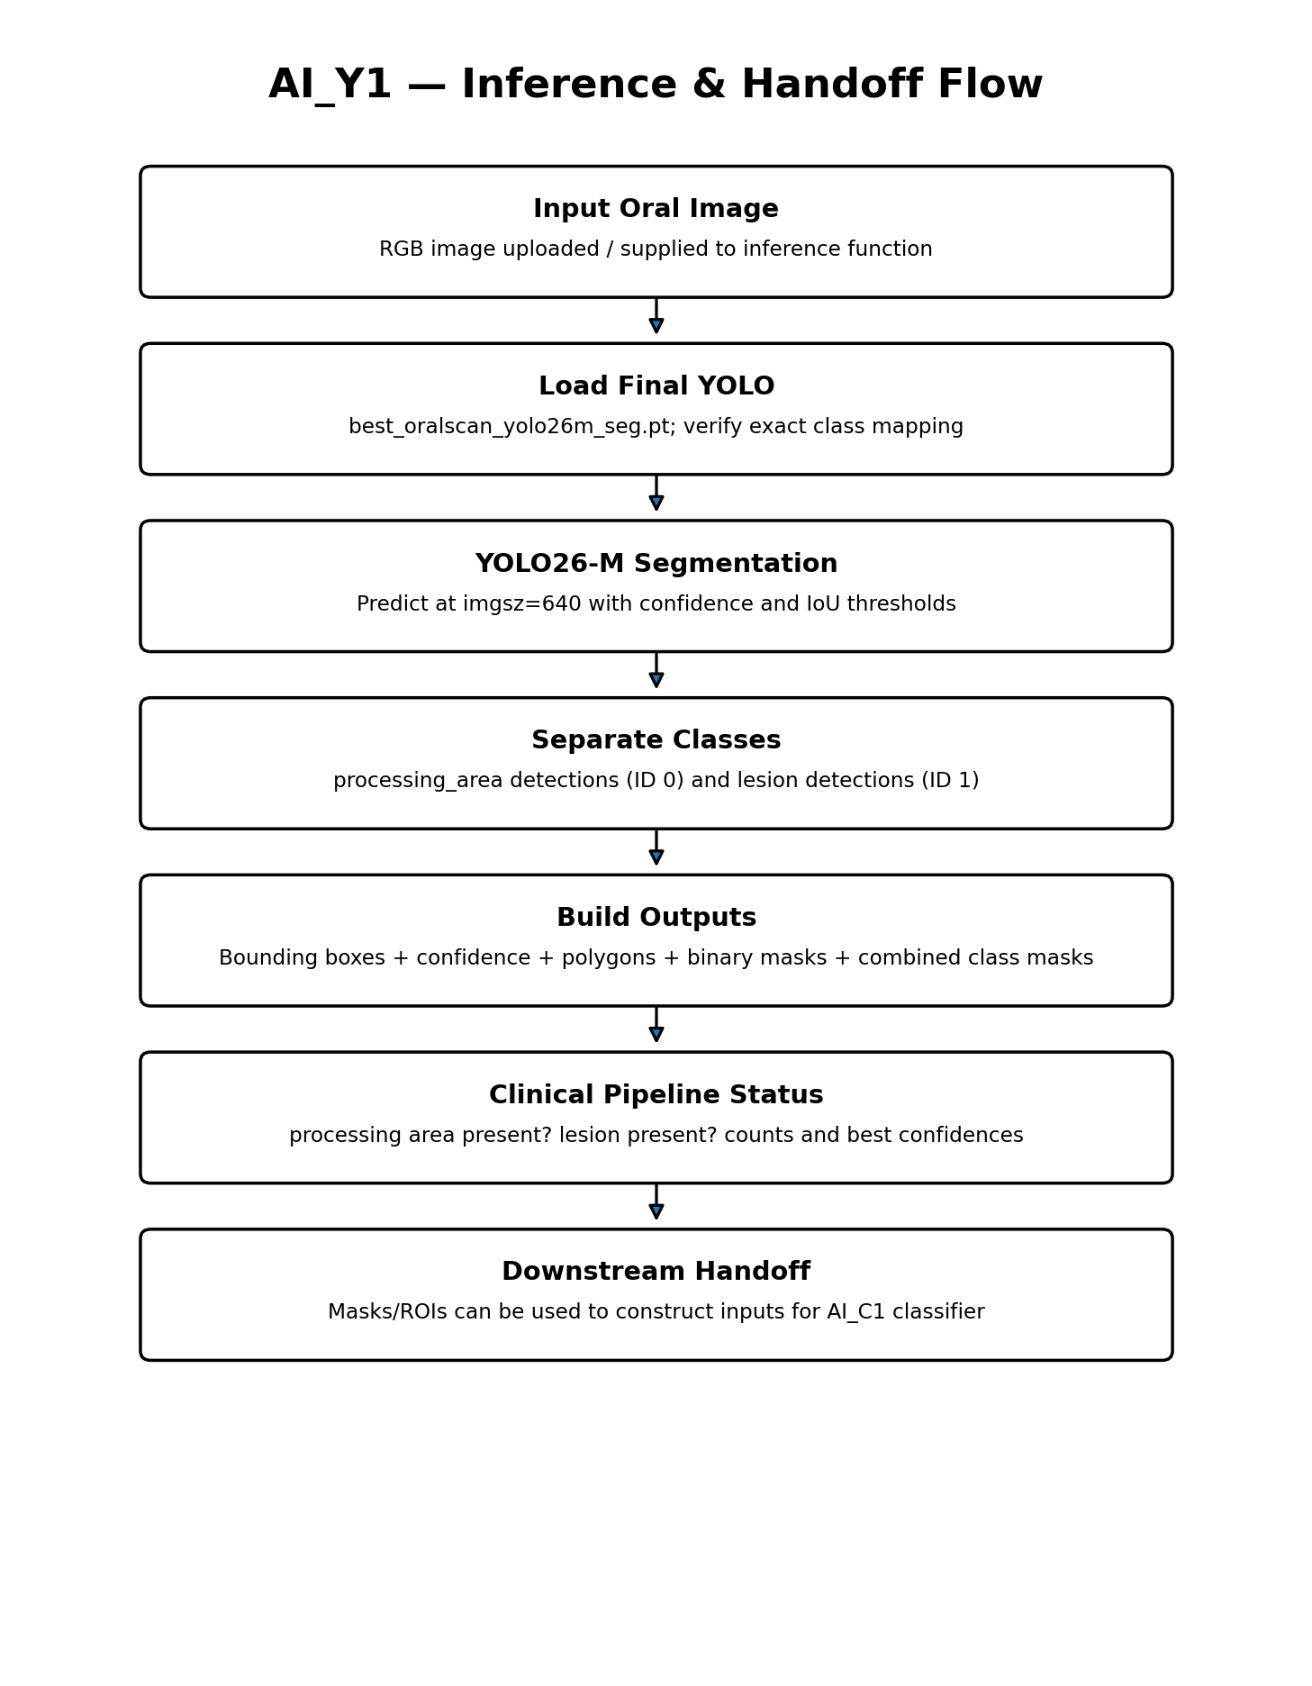

9.1 Runtime defaults
Inference parameter | Default
Model | best_oralscan_yolo26m_seg.pt
Expected classes | {0: 'processing_area', 1: 'lesion'}
Confidence threshold | 0.25
IoU threshold | 0.60
Image size | 640
Output policy | Inline; no ZIP / no output files in the custom inference cell

9.2 Per-detection outputs
- Class ID and class name
- Confidence score
- Bounding box coordinates and dimensions
- Binary segmentation mask resized to original image size
- Mask pixel area and image coverage
- Polygon coordinates / polygon point count
- Separate detection records for processing_area and lesion

9.3 Combined image-level outputs
- Combined processing_area mask
- Combined lesion mask
- processing_area_detected and processing_area_count
- lesion_detected and lesion_count
- Best confidence per class
- Human-readable final status such as “processing area detected; no lesion detected”

10. Recorded Inference Example
A recorded notebook example used a 640×640 image and produced one processing-area detection with no lesion detection.
Field | Recorded value
Total detections | 1
Processing-area detections | 1
Lesion detections | 0
Best processing-area confidence | 0.9564
Processing-area box | [90.7, 155.8, 556.78, 640.0]
Mask pixel area | 189,603
Image coverage | 46.2898%
Polygon points | 550
Final status | Processing area detected; no lesion detected.

11. How AI_Y1 Connects to AI_C1
The same YOLO model is later reused as a region generator for the classifier dataset. AI_Y1 therefore has two operational roles: (1) standalone segmentation inference and (2) ROI/mask generation for AI_C1.
AI_Y1 output | Use in downstream classifier workflow
processing_area mask | Defines anatomically relevant oral tissue ROI; also supports normal-source samples
lesion mask | Defines disease-focused ROI for cancer, leukoplakia and leukoplakia-like samples
confidence scores | Used to decide whether predicted regions are sufficiently reliable
mask area / geometry | Used for crop creation and minimum-lesion checks
original split identity | Preserved so downstream generated classifier samples retain source train/valid/test structure

Study Note: AI_Y1 has one final segmentation model. AI_C1 is a separate classifier model. The downstream dual-ROI design does not mean there are two YOLO models.

12. Reproducibility Checklist
- Use the same source ZIP or equivalent four datasets with their data.yaml files.
- Confirm frozen class order before training: 0=processing_area, 1=lesion.
- Run extraction/remapping/merge before training.
- Review excluded_invalid_samples.csv and cross_split_duplicates.csv.
- Run final merged-dataset polygon audit and class-balance checks.
- Train from yolo26m-seg.pt using the documented configuration.
- Use early stopping and retain best.pt rather than last.pt.
- Reload the copied final .pt and verify model.names exactly.
- Evaluate on the intended held-out split and preserve the metrics JSON.
- For inference, keep class IDs and confidence/IoU semantics identical to the documented pipeline.

13. Study Summary — Read This to Recall the Whole Pipeline
In one sentence: AI_Y1 merges four oral segmentation datasets into a two-class instance-segmentation problem, trains one YOLO26-M segmentation model, and outputs processing-area and lesion masks/geometry that become the spatial foundation for AI_C1 classification.
Question | Answer
How many final YOLO models? | One.
Which architecture? | YOLO26-M segmentation (yolo26m-seg.pt transfer learning).
What are the final classes? | 0=processing_area, 1=lesion.
How many valid merged images? | 812.
Which checkpoint is final? | best.pt copied as best_oralscan_yolo26m_seg.pt.
Why not last.pt? | The notebook deliberately deploys the best validation checkpoint selected during training.
What does YOLO give AI_C1? | Processing-area ROI, lesion ROI, masks, geometry and confidence information.
Does YOLO itself classify cancer vs leukoplakia? | No. Disease classification is handled by AI_C1.

14. Source Provenance
This document is derived from the code and recorded outputs contained in the uploaded notebook ai_y1(3).ipynb. Values such as dataset counts, excluded samples, training duration, best epoch, evaluation metrics, model size and inference example are taken from that notebook run. No external web sources were used.

